Lab 8

Shiyu Wang

Hao Jiang

8.1

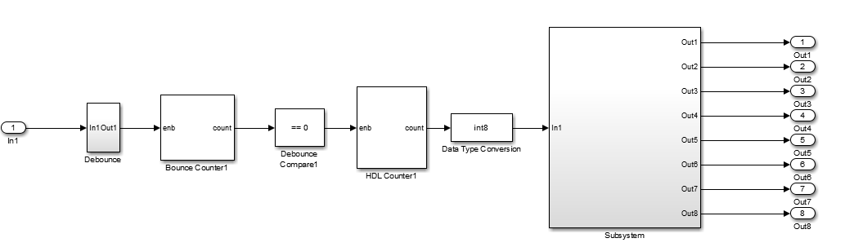

Where In1Out1 is the push button on/off from lab6.

And the subsystem is the bit slicer.

We want the counter to count as 2Hz, which means 2 cycles per second. Since the HDL counter will be counting at a frequency of 50 MHz. We will set the bounce Counter count from 0 to 25000000.

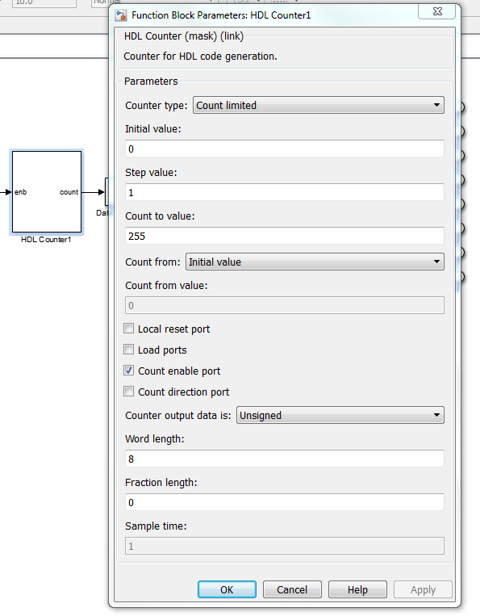

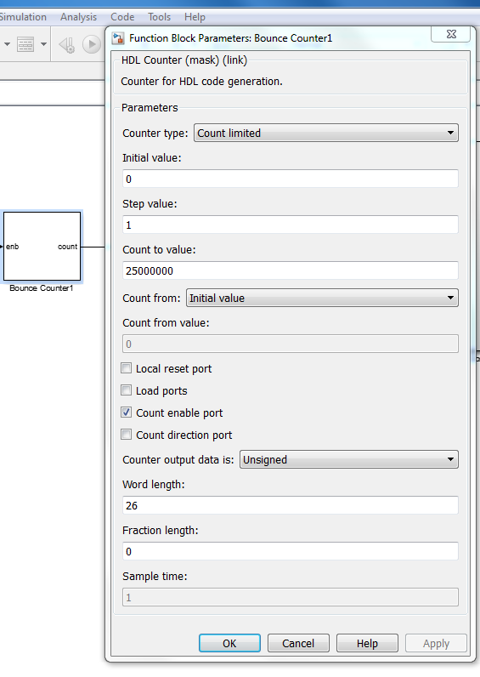

Set Target Interface: Use the center button to control the LEDs to stop/run

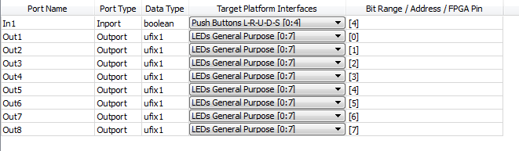

8.2

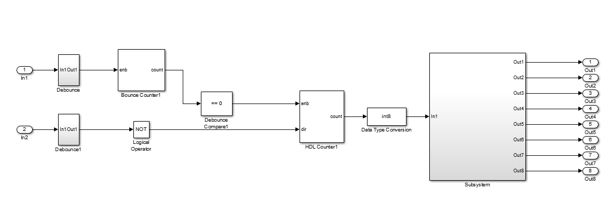

Set Target Interface: Use the center button to control the LEDs to stop/run; Use the right button to change the direction.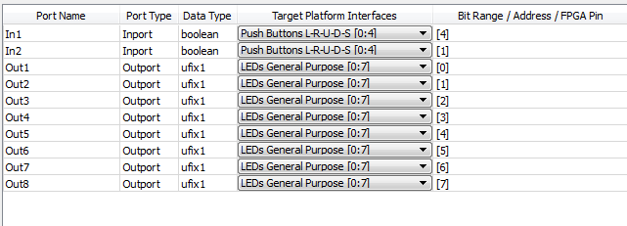

8.3

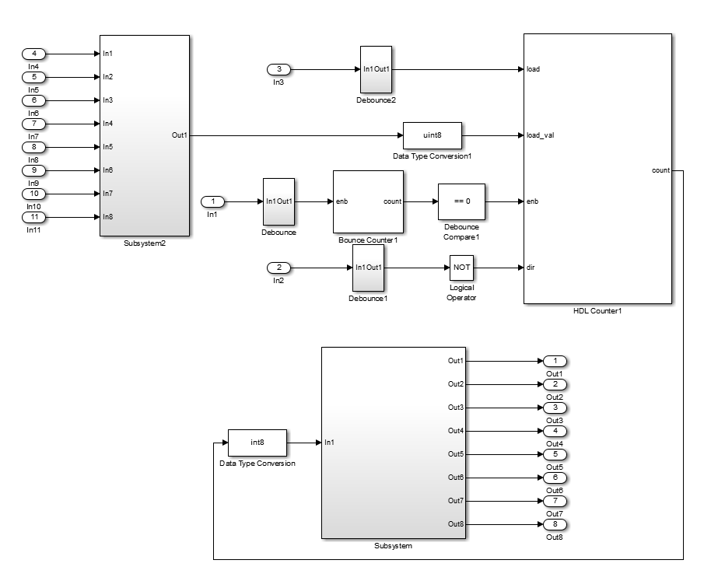

Subsystem2 is from the previous lab which load the switch and then we translate it into the load value.

Set Target Interface: Use the center button to control the LEDs to stop/run; Use the right button to change the direction. Use the left button to load the switch.



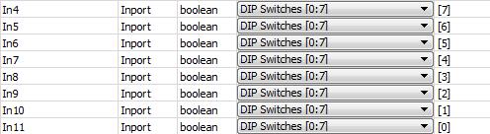

Where input 4 is corresponding to the highest digit and input 11 is the lowest digit.

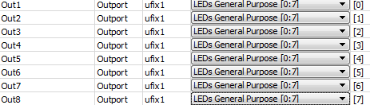

8.4

